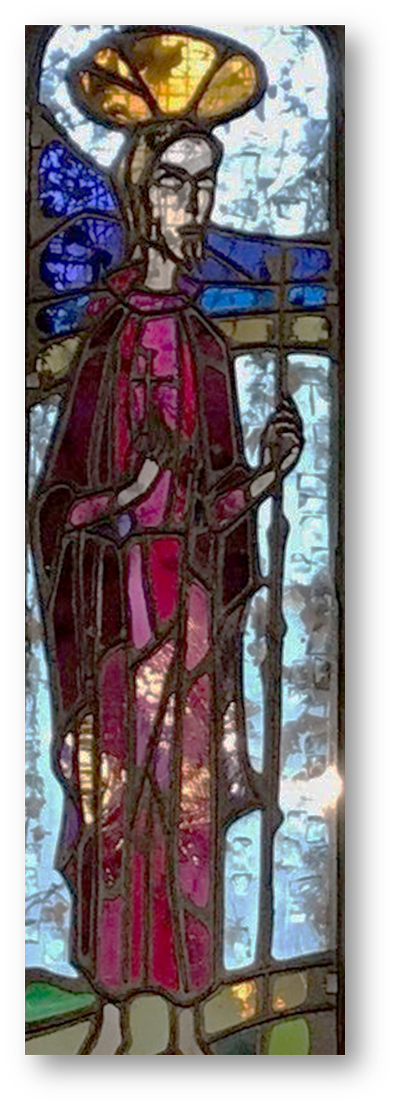
SAINT CADOC

History
and
Legend

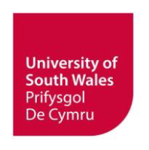
The writing, printing and distribution of this pamphlet were funded by the University of South Wales / Prifysgol De Cymru.
www.southwales.ac.uk

© Kevin Mills 2019

The cover image shows a detail from a window in St Catwg’s Church, Gelligaer. Photograph by Vic Mills.

The reproduction of all or part of this publication is freely permitted, providing its use and/or distribution is conducted on a not-for-profit basis, or in the pursuance of charitable ends.

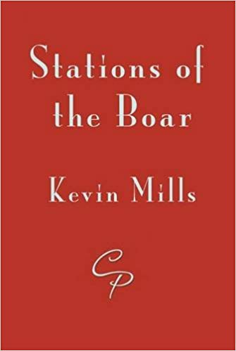
Stations of the Boar is a short collection of poems based on the life of St Cadoc. It is available from Cinnamon Press
https://www.cinnamonpress.com/

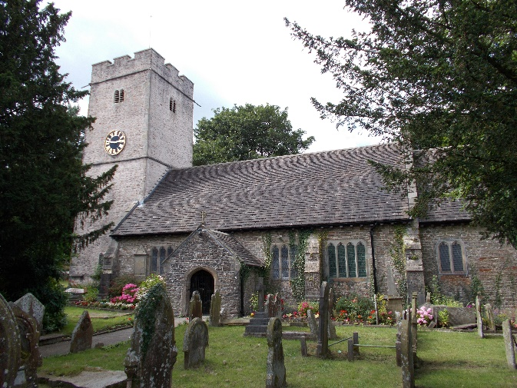
The village of Gelligaer, whose parish church is dedicated to St Catwg, lies in the Caerphilly area of south-east Wales, sitting on a ridge between the Rhymney and Taff valleys. It was an important site for Roman control of the region, being home to a small but significant fort garrisoned by some 500 men. A wooden structure, built between 74 and 78 AD, was replaced between 103 and 111 AD by a stone compound. According to some accounts, it was here that St Catwg (Cadoc in the anglicized form) was born towards the end of the fifth century, or early in the sixth, his birth attended by a number of miraculous occurrences. He was, by reputation, one of the founders of Christian Wales, whose influence helped to shape the country in the early post-Roman period.
POST-ROMAN
WALES
Just outside the village to the north west, Heol Adam follows the route of the Roman road out onto an extensive upland moor that stretches northwards as far as the edge of Merthyr Tydfil. The road passes the historic Cross Inn – where the great preacher John Wesley is said to have stayed in 1744 – and in a nearby field a large stone can be found, cup-shaped indentations cut into its surface. The markings are said to date from the Bronze Age, though their purpose has never been established with any certainty. It is known as Maen Catwg: ‘Catwg’s stone’.
St Catwg's Church, Gelligaer
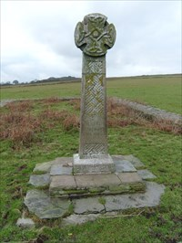
These now depopulated uplands are layered with history and prehistory: four Roman camps have been found, a number of Bronze-Age sites identified, an early Christian standing stone erected, and outlines of medieval platform houses traced in the ground. At Capel Gwladys, just north-east of the junction where Heol Adam joins the road to Bargoed, a replica Celtic cross marks the location of a fifth/sixth-century church. The Gwladys from whom it takes its name was, reputedly, Cadoc’s mother. The parish church of Bargoed is also named after her – the only one in Britain with such a dedication.
Capel Gwladys
Whether or not Cadoc was born here, he and his family certainly left their mark on the area, no less discernibly than in the place most closely associated with him: Llancarfan in the Vale of Glamorgan.
Early post-Roman Wales was divided into multiple kingdoms that in many respects derived from the tribal chiefdoms familiar to the Romans. The geography of the country made it difficult to traverse, and almost impossible to unify either politically or culturally. This meant that rulers were local, and their kingdoms relatively small. They were often on hostile terms with their neighbours, disputing, skirmishing, and raiding seeming to be the chief functions of leadership. Cadoc is said to have been the son of one such ruler: Gwynlliw (also known as Gundleus and Woolos). A local king with a reputation for lawlessness, his territory was the south-eastern corner of Wales, taking in much of modern Gwent and Glamorgan. Cadoc’s main area of influence seems to have been closely associated with this region, stretching (roughly) from the Gower peninsula to the Severn, and from the south coast as far north as the Brecon Beacons.
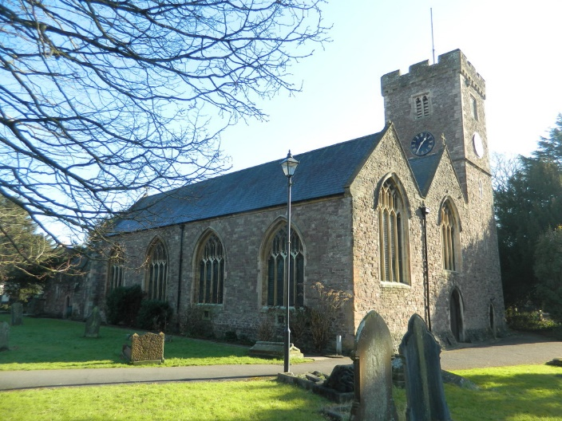
It has been said that place names tell us more about the existence of saints and the organization of the post-Roman church than any other source of information. They have printed onto the landscape traces of travel, settlement and religious activity. As E.G. Bowen shows, the names of churches, villages and monuments strongly suggest that Cadoc’s influence followed Roman roads. Churches dedicated to him are clustered in the eastern part of the Vale of Glamorgan, and around Llangattock (near Crickhowell). Roman influence was considerably less marked to the west of a notional line that might be drawn between these two areas. The fact that important Roman sites at Gelligaer and Caerleon both have churches dedicated to St Cadoc again suggests that his sphere of activity was shaped by the aftermath of the Roman presence in south-east Wales.
St Cadoc’s Church, Caerleon
THE NORMANS IN WALES
The Norman incursions into Wales changed its politics and social organization in profound and lasting ways. English and Norman religious institutions took possession of land and altered the administrative structures of the Church. The new regime had little understanding of the pre-existing patterns of ecclesiastical governance, and was unfamiliar with the ways and means of Welsh religious practice. Welsh churches were often based on the system of clasau: Christian settlements each of which enjoyed autonomy under the rule of a single leader, or abod.
Cadoc is said to have either established, or to have been an early abod of, the clas at Llancarfan (formerly Nantcarvan). Along with the clas of Illtud at Llanilltud Fawr (Llantwit Major), it was probably one of the first seats of learning in Britain, the influence of which spread into Ireland, Scotland, Cornwall and Brittany. The clas-based organization was very different from Norman monastic foundations, and as the latter replaced the former, the cultural shift gave rise to prolonged conflict over the ownership of church buildings, lands and rights. This is very evident from the appendices that can be found attached to the Life of Saint Cadoc, produced early in the Norman era by Lifris of Llancarfan, as well as from the Liber Landavensis (Book of Llandaf). While there are clear disparities between these ancient sources, both make clear that power struggles and land grabs were a significant factor in the way saints and the age of their activity were represented.
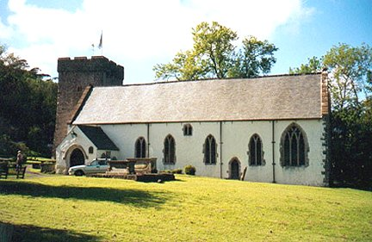
Some of the documents appended to Lifris’ Life strongly suggest that stories told about Cadoc were part of the argument over who owned what. For example, one appendix tells us that:
Guorcinnim bought the village Reathr of Meurig, for his own inheritance, for a sword, the golden hilt of which was worth twenty five cows... Guorcinnim himself gave this village to the church of Saint Cadoc in perpetual possession until the Day of Judgement.
St Cadoc’s Church, Llancarfan
Such claims make sense precisely inasmuch as ownership of the territory they name was disputed, or likely to become so, at the time the text was written. This may help to explain why cults of saints enjoyed a resurgence in the Norman period: they both registered the competing interests of parties in the religious and political upheaval, and served as reminders of pre-Norman practices and traditions. The renewal of interest in the local saints led to many of the Church dedications that remain in place today. Although this process occurred during the Norman period, the associations between specific saints and designated places was not an innovation of that age. That such connections revived older traditions rather than forged new ones, is suggested by the fact that Cadoc’s area of influence can be related, with some confidence, to the geopolitical legacy of Roman rule.
THE LIFE OF SAINT CADOC
While there is compelling evidence for the existence of Cadoc, there is little reliable information about him. Lifris’ Life is far longer and more detailed than other Welsh Lives of saints, and Caradog of Llancarfan subsequently rewrote it in the early twelfth century, but these sources have little to commend them as accurate historical records. Trafficking in unlikely events, spurious claims and exaggerated achievements, they tell some fascinating stories, but lack credibility as biographical sources.
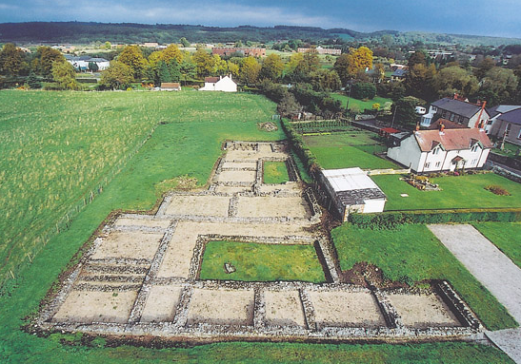
Cadoc appears, too, in a number of Irish hagiographies as a teacher of saints who travelled to Wales to join his community. Despite this comparative wealth of material, details such as where and when he was born, where and when he died, and where he is buried, are subjects of speculation rather than knowledge. His birth is usually said to have taken place in either Newport or Gelligaer, his death at Llancarfan, or Benevento (Italy). His alleged presence at Benevento is probably a mistake: there was a Bannaventa near Daventry in Northamptonshire, which might have been his actual destination. Perhaps more significantly, Edmund McClure suggests that documentary evidence points to a Beneventum much closer to Llancarfan, and that Venta Silurum (the Roman name for Caerwent) fits the case. Cadoc might be buried at either site associated with his death, or at Mamhilad (a few miles north of Pontypool). Lifris tells of Cadoc’s remains being carried from Llancarfan to Mamhilad in order to preserve them from the depredations of a marauding English viscount.
Archaeological remains at Caerwent
Quite apart from the difficulty of establishing the accuracy of information about the so-called ‘Dark Ages’, the details of Cadoc’s life are problematical because the Welsh saint has been confused over generations with other figures of around the same period: Cadog, son of Brychan (died c.490) and the Breton St Cadou, among them. It seems likely that most accounts of St Cadoc interweave details of the lives of more than one individual quite indiscriminately, and there is now no historically robust way of unpicking the knot. The problem has been complicated further by the work of Iolo Morganwg (1747-1826), who almost certainly forged the ‘Sayings of Cattwg the Wise’, included in volume three of The Myvyrian Archaiology.
With these provisos in mind, it might be reasonable to assume that a broad outline can be given of Cadoc’s life that bears some relation to real events. Educated by St Tathan at Caerwent, he subsequently became an itinerant teacher until he found a home at, or established, the clas at Llancarfan. At some point, he travelled to Ireland to advance his studies, before returning to Wales bringing with him a few Irish followers. His education continued under Bachan: an Italian teacher of classical rhetoric (sometimes identified with St Fagan). The stories of Cadoc’s travelling to Brittany and settling for a time on the Ile de St Cado in Morbihan may be the result of his misidentification with the Breton saint. He is said to have built a monastery in Scotland (close to Kilmarnock), and to have undertaken pilgrimages to Rome and Jerusalem. His death was the result of an attack on a church, probably by Saxon soldiers; tradition has him run through with a spear or lance at the altar, midway through the Mass.
STORIES
If the biographical details are both sketchy and uncertain, the stories that grew up around Cadoc over some five hundred years following his death, are rich in striking events, powerful images, and mythological resonances. The subject of two Norman hagiographies (accounts of saints’ lives), he has spawned more legend than any other Welsh saint. The hagiographies depict him as a hard-bargaining, clever, and tough-minded individual, with a sharp sense of his own power, and as committed to a sometimes rather vindictive theology that saw his enemies peremptorily destroyed by divine intervention.
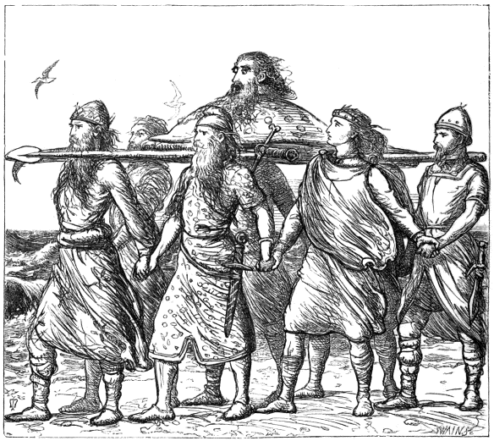
Lifris records some memorable tales. If they are often far-fetched, they are also a fascinating blend of pagan and Christian traditions. At times they are redolent of Celtic mythology, and bear resemblances to stories found in the Mabinogion. In one of the following stories, for example, the cows that Arthur demands as compensation for the death of three of his men, are said to have the fore part red, and the hind part white. They are thus coloured similarly to the otherworldly hounds encountered by Pwyll in the First Branch of the Mabinogi. In Celtic mythology white animals are consistently connected with the otherworld. The white boar encountered by Cadoc in another of the stories included here, probably derives from the same pagan tradition.
The story of the dead architect whose severed head speaks to convict his killers, echoes the tale of Bran whose severed head continues to speak to his companions in the Second Branch, while Lifris’ account of the mouse that helped deliver Brycheiniog from famine, might be thought to echo Manawydan’s encounter with mice in the Third Branch.
Bran’s head carried by his companions
Adding to the store of what we might call ‘Celtic’ tales, and contributing to the compendium of Arthurian literature, these stories form an important part of the history and heritage of the region. They should be remembered and celebrated as contributions to the religious and cultural life of Wales, and of Britain more generally.
The following stories are told in the words of Lifris of Llancarfan, as translated by William Jenkins Rees in 1853.
The White Boar
The venerable man with his clergy passed the following night in prayers to God, that he would inform them of a place to build on for him, and by grubbing up the bushes to make plain. For in that valley there was no dry place, it being a watery moor, producing nothing but reeds, and it was full of various kinds of reptiles and snakes, except what surrounded a bush, under which a great white boar usually passed its time; also in the middle of the said bush, in the upper part, a swan was accustomed to build its nest every year. And as the venerable man finished his prayer, lo, an angel of the Lord appeared in a dream, and said to him, "Thy prayer has been heard by the Lord; therefore on rising early in the morning, thou wilt find a place for building an oratory, plain, and made level, and when thou wilt walk over it, thou wilt see a bristly white old boar leaping, being affrighted at the noise of thy footsteps; and there thou mayest lay the foundation of thy church in the name of the Holy Trinity; afterwards in the place where the boar will again stop, thou mayest build a dormitory, and again, where, in his progress, he will make a third stopping, there thou mayest construct thy refectory."
And Saint Cadoc rising early in the morning, saw that the rough and bushy places had, by the direction of God, been made level, as the angel had mentioned. Therefore the venerable man came by the angelic command to the aforesaid bush, in the middle of the cleared valley, and observed a remarkable great boar rising from the sound of his footsteps, and also a white swan flying away, being driven from its nest by fear. And the boar stopped its course not far from the aforesaid thicket, and looked back towards Saint Cadoc, as if pointing out the place: it then proceeded a little farther, and again for a little while stopped its progress. Then the blessed man marked by the fixing of three twigs, the three stations of the boar; and he built in the first station a remarkable monastery of wooden materials, in the second, a refectory and castle, and in the third, a dormitory.

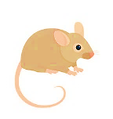
The Famine and the Mouse
And at that time there was a great famine in the district of Brecknock. When the holy man came to the aforesaid dogmatist [Bachan] Saint Cadoc suppliantly asked him, if he would deign to take him to be instructed; to whom he answered, "My son, I am ready, but I am very apprehensive lest food for thee, and thy fellow disciples should be wanting, and ye should suffer from hunger."
These things being heard, the man of God, having strong confidence in the Lord, and urgent in his supplications, watered his sorrowful cheeks with tears, that he might be provided with food for them, by the Giver of all things; wherefore in the course of that day, it happened that a certain mouse went out of its hole carrying in its mouth a grain of corn to the blessed Cadoc, and in a playful manner placed it on a table before his eyes. The same mouse came and returned seven times, and hid as many grains in its heap, showing by a sign that the divine mercy was present with him. At length he caught the same little mouse, and tied it by the foot, that he might diligently search into the mystery of the affair; afterwards he sent for the aforesaid scholastic, drew out the grain, and related to him minutely what had been done.
Both persons knowing that a miracle had been made known to them by God, took counsel together, and Cadoc asked and received from a certain widow, a long and fine thread, which he tied to a foot of the mouse, and letting it proceed with the loosened thread, he followed it, until the said little animal came to a certain mound under which was a very beautiful subterranean house, built of old, and full of clean wheat. And there it presently went in, through a dark hole, and soon returned bringing in its mouth one grain of corn as before. But who had built that house, or who had placed there such a large quantity of corn, is hitherto unknown.

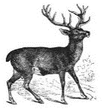
The Stags and the Book
Also another miracle of the same venerable father is said to have taken place; for when he returned to his own town of Llancarvan, from whence he had been absent for a length of time, he beheld his principal monastery destroyed, and the rafters of the roofs and rubbish of the building scattered over the cemetery; and grieving at the ruin, he earnestly desired, with the permission of God, to rebuild it. Therefore he sent for all his clergy and some workmen, and they all went to a grove for the purpose of bringing from thence the materials of timber, excepting two youths, namely Finian and Macmoil, who, with the permission of the man of God, remained that they might pass the time in reading. Then the steward, the cook, and sexton coming forwards, scolded them, saying, "How long will you be disobedient, without doing any good with your fellow disciples? Disliking to work, ye eat the bread of idleness; therefore hasten to the wood, and bring the timber here quickly with your companions." But they answering, said, "We are not able to draw carts after the manner of oxen." But they shewed to them in derision two stags standing near the wood, and said as follows, "Lo, two very strong oxen stand near the wood, go quickly and catch them." And they going, through their great haste, left a book open in the place where they sat, in the open air; and in the name of Christ they ordered the stags to stop, who immediately set aside their wildness, and being gently covered, they submitted their untamed necks to the yoke.
And they brought them home, as domestic oxen, a great beam fastened to their yoke, which four powerful oxen could scarcely draw, and then being loosened from their yoke were allowed to return to their pastures. And Saint Cadoc beholding and greatly admiring what was done, enquired of them, saying, "Who ordered you to come to me to give your assistance to draw the timber without being dismissed from your reading?" And they related to him the reproaches of the aforesaid three persons railing against them; and he, being inflamed with anger, inflicted a curse on the aforesaid three officials, as follows, "May God do this to them," and he added, "that those three persons die by the worst death of a sword, or be killed by hunger." In that very hour, a heavy shower of rain fell throughout the whole district, and the man of God enquired of the aforesaid disciples where they had left the book. And they being afraid said, "In the place where we were employed in reading it, being forgetful through great haste, we left it exposed in the open air." And the man of God went to it, and greatly wondering, found the book altogether uninjured by the rain.

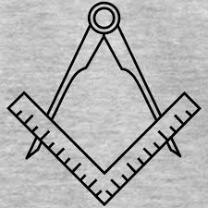
The Murdered Architect
Wherefore it happened that a certain Irishman, named Linguri, a stranger, but a skilful architect, being forced by poverty, came to him [Cadoc] with his children, that by the practice of his skill, he might procure food for himself and family, and he was gladly received by the man of God, and engaging in the work, with twelve workmen, very soon excelled them all in skill and ability. But the other twelve envying him, wickedly killed him; and cutting off his head, they fastened a great stone to the trunk of his body, and cast it into a deep pool. When they, according to custom returned home, the sons of the skilful person not seeing their father as usual, wept with lamentable expressions. And when the man of God heard the wailing, he quickly enquired the cause of such mournful lamentation.
The workmen thereupon being quickly called together, excused themselves with all their might, and with much cavilling asserted that they did not know what had become of the aforesaid architect. Therefore the man of God in order to be informed of their wickedness, passed the night with all his clergy in watching and prayer, that therein the truth of the matter might be declared to them. In the morning when prayers were ended, lo, the beheaded architect, carrying his head in his bosom, and a large stone on his back, and wet and bloody, with a woeful and horrid countenance, appeared to the venerable man, and his disciples. Wonderful to be said, but easily to be effected by God, the head which had been cut off spoke as follows: "Servant of God, fix me on the neck, in the former state, and I will relate to thee everything concerning this matter, which hitherto are unknown to thee." And he did as requested. And the murdered architect, Linguri, related to him the dreadful crime of the aforesaid twelve workmen, and how that being excited by envy, they had villainously slain him. To whom he said in answer, "Choose which you wish to have of these two things, whether to live again in this mortal state, and become a future dead body, or to return to eternal life to reign for ever with God." And he said, "Sir, that my soul may return to eternal life." And while he yet spoke, he expired. Therefore the holy man ordered his disciples to place the aforesaid stone, which the murdered architect had carried on his back, upright in the earth, near the wood, in memory of the miracle, and to bury him there nigh to it, and directed that all the township should be called after his name Lanlynguri (Glynleiros).

King Arthur and the Cattle
Therefore at that time, a certain brave general of the Britons, named Ligessawc, the son of Eliman, who had also the surname of Lawhir, that is Long Hand, slew three soldiers of Arthur, the most illustrious king of Britain; and Arthur pursuing him everywhere, he found no safe place, and no one ventured to protect him for fear of the aforesaid king; until at length being wearied by very frequent flights, he came a fugitive to the man of God. Who commiserating his labours kindly received him, trusting in the Lord, and not fearing Arthur, according to our Lord's command, "Fear not those who kill the body, and cannot kill the soul, but rather fear him who can kill both body and soul in Hell." Therefore he remained with him safe in the country of Gwynllwg, without the knowledge of Arthur, for seven years. Which being passed, he was betrayed to the said king, and the same at last came with a large force of soldiers to the river Usk, for the sake of pleading in a trial at law, for he dared not to contend with violence against the man of God. Therefore he sent ambassadors to the king, and enquired of him if he would refer the dispute to the verdict of skilful judges. And he acquiesced, for Saint Cadoc having sent for three principal persons from divers parts of the country, namely David and Teilo and Dochu (Oudoceus), and also Keneder (St. Cynidr) and Maidoc (Aeddan Foeddog - St Aidus), with many other clergymen, and senior judges of all Britain, who, assembling on the banks of the great river Usk, met together, he preceding them.
There also, after the manner of enemies, they disputed the matter with bitter words, from both sides of the river, and contended for a length of time against each other. After an intermission in the altercation, the more skilful of the judges decreed that Arthur ought to receive for the redemption of every one of his men, who was slain, three very good oxen. Others however fixed that one hundred cows should be given as the price of every person who had been killed; for from ancient times the judgment among the Britons was of this kind, and the price was appointed by the ministers of kings and generals.
This being accepted, Arthur, in an insolent manner, refused cows of one colour, but would have those of two colours: with the fore part red, and the hind part white, and required those so distinguished by colour, with much wrangling. And they, being altogether ignorant where cattle of that colour were to be found, were in doubt what they should do respecting them. Therefore the man of God, in the name of three persons, ordered young men of the company, to the number of nine, or more as some say, to bring to him one hundred heifers, of whatever colour they might be. And when the said animals were brought before his eyes and those of other servants of God, they were, on account of the perverse desire of Arthur, immediately turned into the aforesaid colours.
And the company of all the clergy, and many other faithful worshippers of God, who had been assembled by the blessed man, beholding this miracle, greatly rejoiced, and glorified God. Moreover the man of God consulted what ought justly to be done respecting the aforesaid cattle, and an answer was given from one of the sides of the company of judges, "It is right that thou shouldest drive them in a flock to the middle of the ford." Therefore he drove them until Arthur Kai and Bedwyr with others sitting on the banks of the river met them; and Kai and Bedwyr, greatly desiring to have them, drew them by their horns with their hands to the river's side; but immediately, whilst they were in their hands, they were by the direction of God changed into bundles of fern. Which miracle being seen by Arthur, he humbly entreated the blessed man that the injury which he had inflicted on him should be forgiven him. And pardon for the offence was granted to him, according to the evangelical precept, "Forgive and ye shall be forgiven."
SOURCES AND FURTHER READING
Andrewartha, Clive, ‘Roman Gelligaer’, Gelligaer Vol. XIV (Gelligaer Historical Society, 2004), 3-8.
Bowen, E.G., The Settlements of the Celtic Saints in Wales (Cardiff: University of Wales Press, 1954).
----------------- Saints, Seaways and Settlements in the Celtic Lands (Cardiff : University of Wales Press, 1977).
Cartwright, Jane (ed.), Celtic Hagiography and Saints’ Cults (Cardiff: University of Wales Press, 2003).
Charles-Edwards, T.M., Wales and the Britons, 350-1064 (Oxford: Oxford University Press, 2013).
Davies, John, A History of Wales, 2nd edition (London: Penguin, 1993, 2007).
Davies, Sioned (trans.) The Mabinogion (Oxford University Press, 2007).
Davies, Wendy, Wales in the Early Middle Ages (Leicester: Leicester University Press, 1982).
Doble, G.H., Lives of the Welsh Saints (Cardiff: University of Wales Press, 1971).
Dodd, A.H., A Short History of Wales: Welsh Life and Customs from Prehistoric Times to the Present Day (Ruthin: John Jones, 1998).
Emanuel, Hywel D., ‘An analysis of the composition of the Vita Cadoci’, National Library of Wales Journal, 7 (Summer, 1952), 217-227.
Felstead, Richard, ‘Myth and Folklore in the Parish of Gelligaer’, Gelligaer Vol. XII (Gelligaer Historical Society, 1982), 5-6.
Henken, E.R., The Welsh Saints: A Study in Patterned Lives (Cambridge: D.S. Brewer, 1991).
Hughes, Islwyn, ‘In the Footsteps of St Catwg’, Gelligaer Vol. XVII (Gelligaer Historical Society, 2009), 57-60.
Jack, R. Ian, Medieval Wales (London: The Sources of History Ltd in association with Hodder and Stoughton, 1972).
Knight, Jeremy, South Wales from the Romans to the Normans: Christianity, Literacy and Lordship (Stroud: Amberley Publishing, 2013).
Laing, Lloyd, The Archaeology of Late Celtic Britain and Ireland, c.400-1200 AD (London: Methuen, 1975).
_____________ The Archaeology of Celtic Britain and Ireland: c.AD 400 – 1200 (Cambridge: Cambridge University Press, 2006).
Llewelyn, Dorian, Sacred Place, Chosen People: Land and National Identity in Welsh Spirituality (Cardiff: University of Wales Press, 1999).
McClure, Edmund, British Place-names in their Historical Setting (London: SPCK, 1910).
Mills, Kevin, Stations of the Boar (Blaenau Ffestiniog: Cinnamon Press, 2016).
Morgan, Prys, Wales: An Illustrated History (Stroud: Tempus, 2005).
Morris, John, The Age of Arthur: A History of the British Isles from 350 to 650 (London: Weidenfeld and Nicolson, 1973).
Panes, Graham, Voyages of the Celtic Saints (Llanrwst: Gwasg Carreg Gwalch, 2007).
Parry-Jones, D., Welsh Legends and Fairy Lore (London: B.T. Batsford, 1953).
Pierce, Gwynedd O., Place-Names in Glamorgan (Cardiff: Merton Priory Press, 2002).
Rees, Elizabeth, Celtic Sites and their Saints (London: Burns and Oates, 2003).
Rees, William Jenkins (trans.) Lives of the Cambro British Saints (Llandovery: William Rees; London: Longman; Abergavenny: J.H. Morgan, 1853).
Ross, Anne, Pagan Celtic Britain: Studies in Iconography and Tradition (London: Sphere, 1974).
--------------- Folklore of Wales (Stroud: The History Press, 2011).
Selnick, Christa N., White Sow, White Stag, and White Buffalo: The Evolution of White Animal Myths from Personal Belief to Public Policy (MA Thesis, Georgetown University, Washington, D.C., 2012).
Walker, David, Medieval Wales (Cambridge: Cambridge University Press, 1990).
Williams, Gwyn A., When Was Wales? A History of the Welsh (Harmondsworth: Penguin, 1985).
Williams, Stewart (ed.), The Garden of Wales: The Vale Series, Vol. III (Cowbridge: D. Brown and Sons, 1961).

